<https://filisantillan.com/el-gran-poder-de-css3-flexbox/>

<http://www.mclibre.org/consultar/htmlcss/css/css-flexbox.html>

<https://www.w3schools.com/css/css3_flexbox.asp>

<https://www.w3schools.com/cssref/pr_class_display.asp>

<https://www.w3schools.com/cssref/css_selectors.asp>

<https://www.w3schools.com/cssref/default.asp>

<https://www.w3schools.com/cssref/css3_pr_box-sizing.asp>

# **CSS Flexbox**

The Flexible Box Layout Module, makes it easier to design flexible responsive layout structure without using float or positioning.

To start using the Flexbox model, you need to first define a flex container.

## **Parent Element (Container)**

The flex container becomes flexible by setting the display property to *flex*:

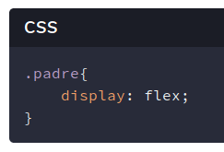

**Flexbox** es un nuevo módulo de diseño en CSS3 para mejorar la forma en que hacemos [**Responsive Design**](https://developer.mozilla.org/es/docs/Desarrollo_Web/Web_adaptable),

FlexBox está constituido por un padre **(Contenedor - Flex)** y sus hijos **(Elemento - Flex)**.

The flex container properties are:

| Properties | Description |
| --- | --- |
| [flex-direction](https://www.w3schools.com/css/css3_flexbox.asp#flex-direction) | **Flex-direction: row || row-reverse || column || column-reverse** Defines in which direction the container wants to stack the flex items.  Esta propiedad define las direcciones del eje principal, hacia donde se moverán los Elementos - Flex, tanto horizontalmente como verticalmente. |
| [flex-wrap](https://www.w3schools.com/css/css3_flexbox.asp#flex-wrap) | **Flex-wrap: nowrap || wrap || wrap-reverse** Specifies whether the flex items should wrap or not.  nowrap: fijar los elementos - flex en una sola línea,  wrap: los elementos ocupan mas lineas si no caben en una |
| [flex-flow](https://www.w3schools.com/css/css3_flexbox.asp#flex-flow) | **flex-flow: <flex-direction> || <flex-wrap>;**  Example: flex-flow: row wrap;  It is a shorthand property for setting both the flex-direction and flex-wrap properties. |
| [justify-content](https://www.w3schools.com/css/css3_flexbox.asp#justify-content) | **Justify-content: flex-start || flex-end || center || space-between || space-around** It is used to align the flex items.  alinea los elementos - flex a lo largo del eje principal de la línea actual (contenedor - flex). |
| [align-items](https://www.w3schools.com/css/css3_flexbox.asp#align-items) | **Align-items: stretch || flex-start || flex-end || center || baseline** It is used to align the flex items vertically.  es muy similar a la propiedad justify-content, pero este es en la dirección del eje secundario. |
| [align-content](https://www.w3schools.com/css/css3_flexbox.asp#align-content) | **Align-content: stretch || flex-start || flex-end || center || space-between || space-around** It is used to align the flex lines.  alinea las líneas de un contenedor - flex cuando los elementos no utilizan todo el espacio disponible en el eje secundario. |

### 

| **Perfect Centering** |
| --- |
| Set both the justify-content and align-items properties to *center,* and the flex item will be perfectly centered:  .flex-container {  display: flex;  height: 300px;  justify-content: center;  align-items: center;  } |
| <https://www.w3schools.com/css/tryit.asp?filename=trycss3_flexbox_perfect_center> |

## 

## **Child Elements (Items)**

The direct child elements of a flex container automatically becomes flexible (flex) items.

## The flex item properties are:

| Properties | Description |
| --- | --- |
| [**order**](https://www.w3schools.com/css/css3_flexbox.asp#order) | The order property specifies the order of the flex items.  Los elementos - flex pueden ser reordenados con esta propiedad sin la necesidad de reestructurar el código HTML.  <div class="flex-container">  <div style="order: 3">1</div>  <div style="order: 2">2</div>  <div style="order: 4">3</div>  <div style="order: 1">4</div>  </div> |
| [**flex-grow**](https://www.w3schools.com/css/css3_flexbox.asp#flex-grow) | Specifies how much a flex item will grow relative to the rest of the flex items. The value must be a number, **default value is 0**.  Esta propiedad especifica el factor que determina hasta qué punto un elemento - flex crecerá en relación con el resto de los elementos - flex.  Si los elementos - flex tienen el mismo valor para flex-grow, todos van a tener el mismo tamaño, según el contenedor - flex  <div class="flex-container">  <div style="flex-grow: 1">1</div>  <div style="flex-grow: 1">2</div>  <div style="flex-grow: 8">3</div>  </div> |
| [**flex-shrink**](https://www.w3schools.com/css/css3_flexbox.asp#flex-shrink) | Specifies how much a flex item will shrink relative to the rest of the flex items.  The value must be a number, **default value is 1**.  Esta propiedad especifica cómo el elemento - flex se reducirá con respecto al resto de los elementos flexibles dentro del mismo contenedor  <div class="flex-container">  <div>1</div>  <div>2</div>  <div style="flex-shrink: 0">3</div>  <div>4</div>  <div>5</div>  </div> |
| [**flex-basis**](https://www.w3schools.com/css/css3_flexbox.asp#flex-basis) | **Flex-basis: auto || width** Specifies the initial length of a flex item.  El tamaño de los elementos viene determinado por su contenido. Si un elemento ocupa más espacio y puede ocupar más, se ensanchará. Esta propiedad tiene los mismos valores que las propiedades width y height y especifica el tamaño principal del elemento - flex, distribuyéndose de acuerdo con los factores flex.    <div class="flex-container">  <div>1</div>  <div>2</div>  <div style="flex-basis: 200px">3</div>  <div>4</div>  </div> |
| [**flex**](https://www.w3schools.com/css/css3_flexbox.asp#flex) | **flex: none | auto | [ <flex-grow> <flex-shrink>? || <flex-basis> ];**  It is a shorthand property for the flex-grow, flex-shrink, and flex-basis properties.  flex: 0 0 200px; /*Make the third flex item not growable (0), not shrinkable (0), and with an initial length of 200 pixels:*/  flex: 1 1 auto; /*auto*/  flex: 0 0 auto; /*none*/ |
| **align-self** | **Align-self: auto | flex-start | flex-end | center | baseline | stretch;**Specifies the alignment for the selected item inside the flexible container.The align-self property overrides the default alignment set by the container's align-items property. |

# 

| Before doing the exercises, practise with these online games. |
| --- |

<https://flexboxfroggy.com>

<http://www.flexboxdefense.com/>

**Imagina que eres un professor de llenguatge de marques.**

Si eres un alumne seleccionat, prepara una classe explicant les activitats assignades.

| Students | Exercises | Exposition |
| --- | --- | --- |
| Substitute () | 1, 2, 3, 4, 5 | Friday 25th November |
| Substitute () | 6, 7, 8, 9 | Friday 25th November |
| Substitute () | 10, 11, 12, 13, 14, 15 | Friday 25th November |
| Substitute () | 16, 17, 18, 19 | Friday 25th November |

# **Exercicis:**

| Cada pàgina web ha d'incloure:   * atribut **lang** * secció <head> amb **meta tags** * secció <body> amb **h1** * images han d’incloure l’atribut **alt** * Semantic tags (headers, nav, main, article, section, footer…) * Utilitza només **CSS External.**   Utilitza només les etiquetes que hem estudiat.  Recorda comprovar els teus exercicis amb: HTML Validator  <https://validator.w3.org/#validate_by_input>  <https://jigsaw.w3.org/css-validator/> |
| --- |

# 

## **1. Stretch all, fixed spacing**

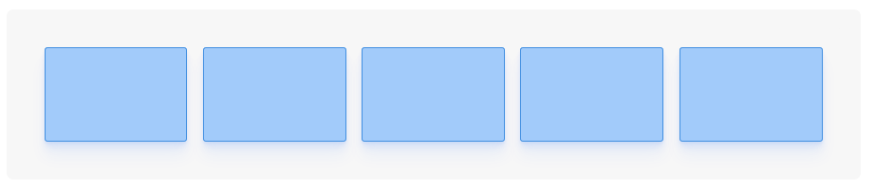

|  |
| --- |

## **2. Stretch middle, fixed spacing**

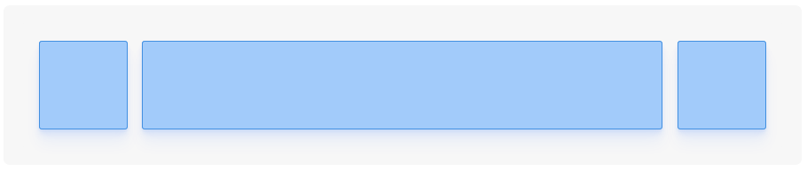

|  |
| --- |

## 

## **3. Alternating grid**

## 

|  |
| --- |

## **4. 3x3 grid**

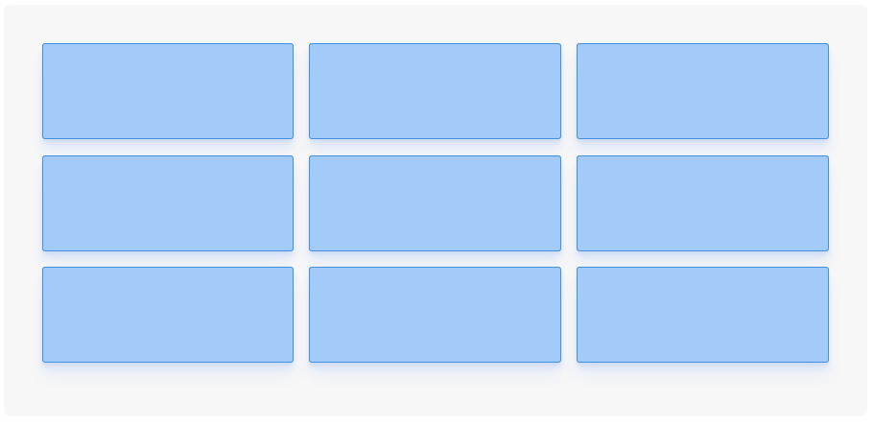

|  |
| --- |

## **5. Vertical stack (centered)**

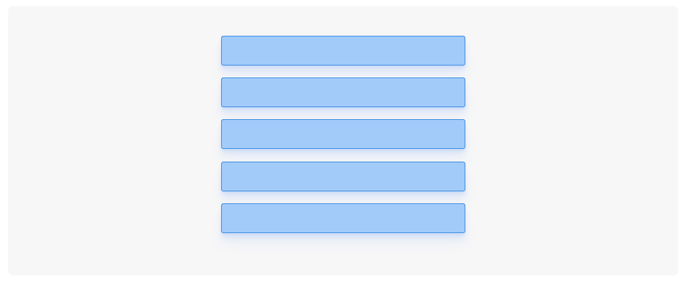

|  |
| --- |

**6. 6 images in the same line with the same size**

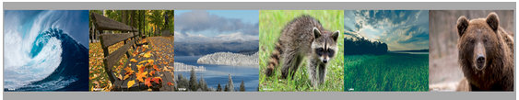

| <img src="pic_trulli.jpg" alt="Trulli">  <img src="img_girl.jpg" alt="Girl in a jacket">  <img src="img_chania.jpg" alt="Flowers in Chania">  <img src="img_food.jpg" alt="Food">  <img src="img_car.jpg" alt="Car">  <img src="workplace.jpg" alt="Workplace"> |
| --- |

**7. 6 images in two lines with different sizes:**

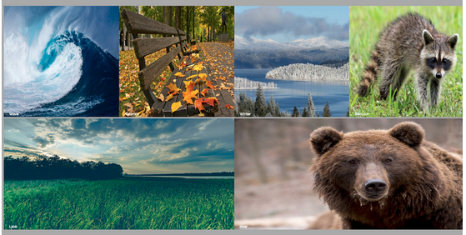

| <img src="pic_trulli.jpg" alt="Trulli">  <img src="img_girl.jpg" alt="Girl in a jacket">  <img src="img_chania.jpg" alt="Flowers in Chania">  <img src="img_food.jpg" alt="Food">  <img src="img_car.jpg" alt="Car">  <img src="workplace.jpg" alt="Workplace"> |
| --- |

## 

## **8. Center an element**

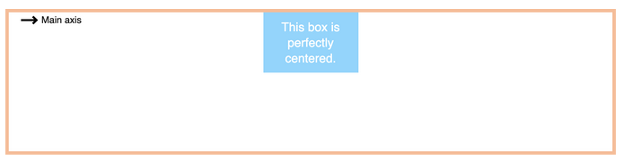

|  |
| --- |

## **9. Perfect Centering**

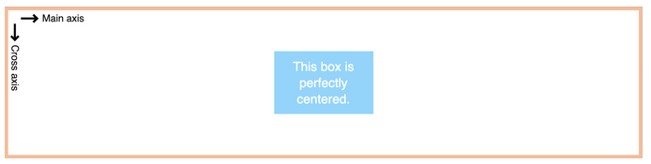

|  |
| --- |

## **10. Main menu (left)**



|  |
| --- |

## **11. Main menu (center)**



|  |
| --- |

## **12. Main menu (right)**



|  |
| --- |

## **13. Main menu (space-between)**

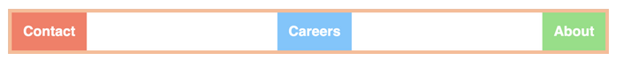

|  |
| --- |

## **14. Main menu (margin)**



|  |
| --- |

## **15. Main menu (growth)**

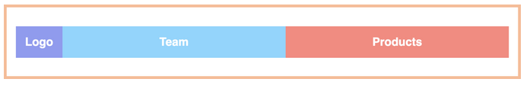

|  |
| --- |

## **16. Element distribution (row, row-reverse, column)**

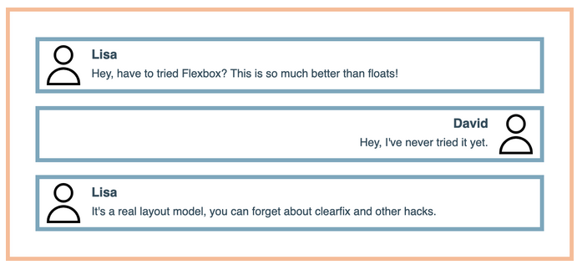

|  |
| --- |

**17. Layout 1**

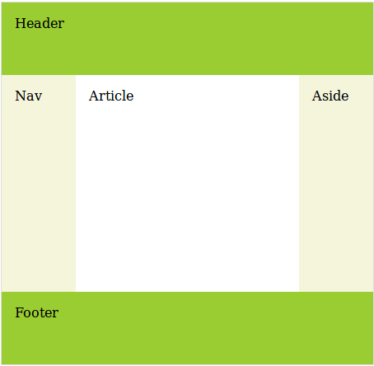

|  |
| --- |

**18. Layout 2**

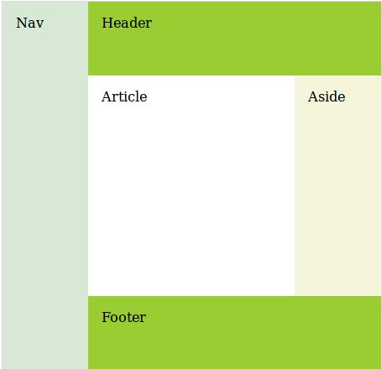

|  |
| --- |

**19. Layout 3**

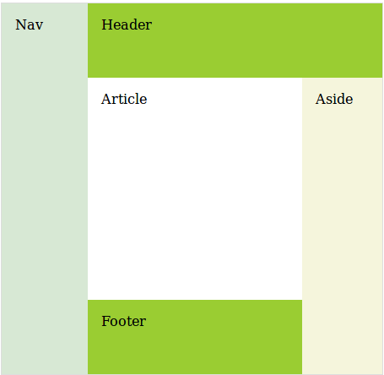

|  |
| --- |

**20. Practise with these compositions (voluntary)**

